**Student Response to Thesis Examiner Reports**

Please use this template to document your responses to all the Thesis Examiners Reports. Please consult the “[Guidelines for responding to examiners' comments](https://qutvirtual4.qut.edu.au/c/document_library/get_file?uuid=b63e76a5-346f-4bc5-9c3c-5b610497e4c8&groupId=16731131&filename=responding_to_examiners.pdf%20)” document before commencing as it provides some examples. Consult with your supervisor prior to uploading this report as it will require supervisor approval via the online final submission of thesis form before the form can be progressed.

|  |  |
| --- | --- |
| Student Name | Stephanie Rose Kobakian |
| Student ID | 10275908 |
| Course | IF80 |

**Examiner One**

|  |  |  |
| --- | --- | --- |
| Examiner Remarks | Thesis Author Comments | Page or other Reference |
| 1.1 I felt it required quite a substantial amount of background knowledge to completely understand the usefulness and usability of the sugarbag package and algorithm. | I agree that the purpose of the sugarbag package may not have been clear enough. The usefulness and usability of the sugarbag package are now explored in more detail throughout Chapter 3. - The introduction to Chapter 3 has also been edited. - A new section called Existing Mapping Practices details the existing alternative displays, and presents the background knowledge needed to understand the usefulness of the hexagon tile map. - Examples of these existing displays can be viewed in figure 3.2. | p. 39 – 43  Appendix items:  A1a and A1b  A2a to A2d     A2b |
| 1.2 I thought it might be preferable to provide an example of what a hexagon tile map looks like before going into the algorithm details. That way, a reader would have some understanding of what the purpose of the algorithm was. | This is a fantastic idea. The hexagon tile map example of Australia has been included in the algorithm chapter. | p. 59  Appendix item: A3 |
| 1.3 Similarly, a high-level sketch of the general approach would be useful for allowing reader to grasp the basics before going into the details. | The Algorithm section presents the general approach as well as a flow chart:  *“The purpose of this algorithm is to create a map display that highlights the spatial distributions for populations. There has been an increasing need for displays that emphasise the large number of people that live in dense urban environments. The algorithm intends to maintain the spatial relationships of a group of geographic units in two ways: between each unit and its neighbours; and between each unit and the closest focal point. The algorithm allocates geographic units to a representative hexagon, in order of their proximity to the closest focal point.”* | p. 44  Appendix item:  A4 |

Remarks specific to Chapter 3:

|  |  |  |
| --- | --- | --- |
| 1.4 Regarding introduction of Chapter 3, it could perhaps use a bit more motivation as to why one would this algorithm over others. | The introduction discusses contiguous, non-contiguous and Dorling cartograms of Queensland to motivate the design choices of the hexagon tile map.  Additionally, the new motivation section 3.2 titled “Existing Mapping Practices” expands on this and includes a figure showing other alternative displays with the Statistical Areas (Level 2) of Queensland, Australia. This section helps to set up the use and need for the hexagon tile map, and the algorithm chapter. Addressing the reasoning behind some of the design choices in the context of presenting spatial disease data. | p. 39; p. 41  Appendix items:  A2a to A2d |
| 1.5 The chapter (and the one previous) does a nice job of pointing out the deficiencies of previous approaches (cartograms, etc.) but does not detail how the hexagon tile map addresses all of those deficiencies. A simple description near the beginning would be valuable, I think, even for those who are steeped in literature of visualization methodologies. It would give the reader (and potential user of the software) a clear understanding of why they are going to use this software over others. | The features and deficiencies of the contiguous, non-contiguous and Dorling cartograms are detailed using the Queensland examples presented in figure 3.2. There are contrasts made of the features of the alternatives and how they compare to the hexagon tile in “Existing Mapping Practices”. | p. 41 – 43  Appendix item:  A2b |
| 1.6 From a software user's standpoint, it is not immediately clear in Chapter 3 what are the key decisions one would have to make before using the software properly. There appear to be a number of options in each of the functions and it's not clear which ones can be left at default values and which ones must be specified by the user. Furthermore, it would be helpful to have some sense of the how sensitive the algorithm is to changes in key parameters. | I have expanded the “User choices” section to explain only two inputs are required to begin using the algorithm the shape file, and the id column. I have explained the use of the other parameters and inputs for each step in the process. Specifically:  *“The centroids derived from the shape file are necessary inputs when creating a grid. The creation of the grid and filtering out the unlikely points to be used in the resulting hexagon map results in the hexagon tile map grid. At this point, the centroid set and the grid become the necessary inputs to the allocation process.”* | p. 45  Appendix item:  A2d |

Remarks specific to Chapter 4:

|  |  |  |
| --- | --- | --- |
| 1.7 Chapter 4 is overall well-done, but I thought something to be added to the discussion is the fact that the hexagon tile map was compared to choropleth maps and not to any of the already-proposed alternatives. I can see why this was done given the extreme popularity of traditional choropleth maps and the need to validate the hexagon tile map in a known setting.  While it is important to know that the hexagon tile map is certainly not worse than the choropleth map, it seems the potential user is still unclear on whether the hexagon tile map should be preferred over, say, a contiguous cartogram or a standard tile map. Such a comparison would perhaps be reasonable to consider in future studies. | Thank you for highlighting that this was not addressed as a limitation of the study. As the reviewer mentioned the choropleth provided a known setting for comparison. It is correct that study does not make claims as to whether the hexagon tile map is a more effective display than contiguous, non-contiguous or Dorling cartograms. The following section has been added to the discussion.  *“The conclusions drawn in this study are limited as it did not contrast the hexagon tile map to other alternative displays. This initial study tested the viability of a new alternative display against the common display for cancer atlases, the choropleth map. This study provides an opportunity for future studies to contrast the effectiveness of this display in the context of other alternatives. This analysis could be extended to contrast the performance of the hexagon tile map display against the choropleth, contiguous, non-contiguous and Dorling cartograms.”* | p. 87 |

Appendix and figure remarks:

|  |  |  |
| --- | --- | --- |
| 1.8 There are numerous places where figures are referenced without their chapter number (e.g. "Figure 3" instead of "Figure 4.3"), which makes the thesis confusing to follow at times. | The figure and table references have been altered to include the chapter before the figure/table number. Throughout all the thesis the Figure referencing now uses the word Figure followed by the chapter number, then figure number. |  |
| 1.9 Figure 4.3 does not appear to be correct as it is labelled as a lineup of hexagon tile maps but they are clearly choropleth maps. | This caption has now been corrected referring to the maps as choropleths.  Figure 4.3 This lineup of twelve choropleth displays contains one map with a real population related structure. The rest are null plots that contain spatial correlation between neighbours. | p. 71 |
| 1.10 The figures in Appendix A.2.C appear off in that the maps identified as choropleth and hexagon tile are identical. | Thank you for identifying this, the issue with creation of the images has been corrected.  The appendix is located in Section A, the maps were located in A.2.C and included Figure A.22, A.24, A.26, A.28 that all show distributions that affects all areas from North West to the South East. | p. 114 - 117 |

**Examiner Two**

|  |  |  |
| --- | --- | --- |
| Examiner Remarks | Thesis Author Comments | Page or other Reference |
| * 1. A minor comment: I don’t think I ever saw a definition of tessellation. There may be a place early on where this could be quickly defined. | I have added to the literature chapter a description of tessellation in this context:  *“Cano and others (Cano et al., 2015) define the term 'mosaic cartograms' for hexagonal tile displays, where the number of tiles for each area or the color of them can communicate the statistic of regions. When using several tiles per region, map makers can adjust the complexity of the boundaries in the resulting display. They can also make a trade-off between boundary complexity and simplicity by the size of the tiles used. A mosaic cartogram employs tessellation to connect the hexagons, triangles or squares used to represent the geographic land mass. Tessellation closely arranges each of the shapes so that the sides of neighbouring shapes align. Tile maps do not have to tessellate completely, this flexibility is helpful if the land mass has islands.”* | p. 27 |
| * 1. Final minor comment: have you tried the package with any non‐Australia regions? | Yes, we have included non‐Australia regions in our testing and development, this included the United Kingdom, and USA. There was a small example of the United States of America in Chapter 2, Figure 2.2d).  However due to the length of this thesis, examples were streamlined to use Australia, and cancer atlas data examples. | p. 23 |
| * 1. PS: Why sugarbag? | This name was chosen due to the behaviour of the Trigona carbonaria bee species. A statement explaining the relationship has been included before the steps of the algorithm are explored in Chapter 3.  *“The algorithm is named for the Trigona carbonaria bee species. Native to northern and eastern Australia this stingless species builds flat layers of hexagonal brood cells, spiralling out from a central point (Vit, Pedro, and Roubik, 2013).* *This hive design inspired the use of multiple focal points in the algorithm, individual spirals are constructed outward from various points on the geographic map base.”* | p.43 Section 3.3, paragraph 2: |



**Appendix  
A1a** 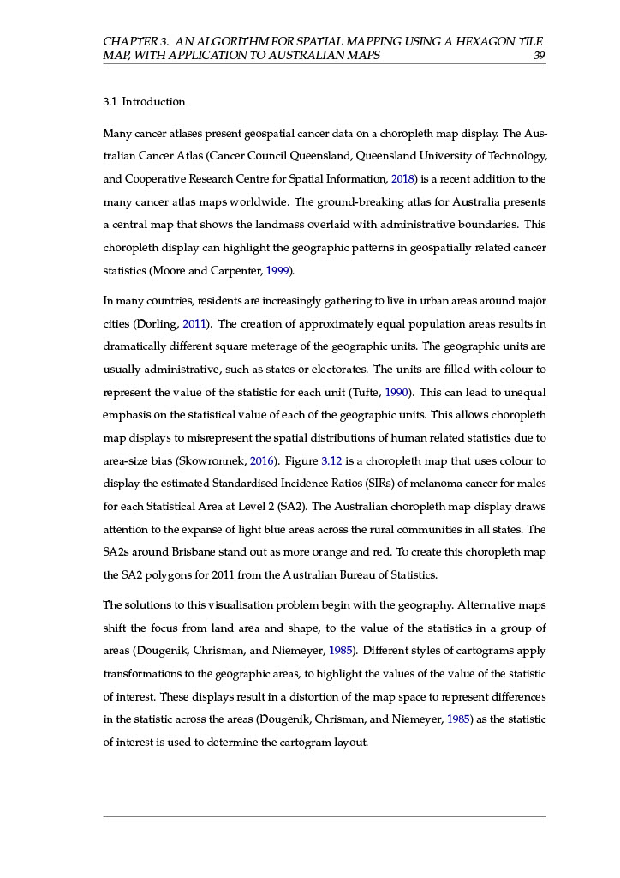

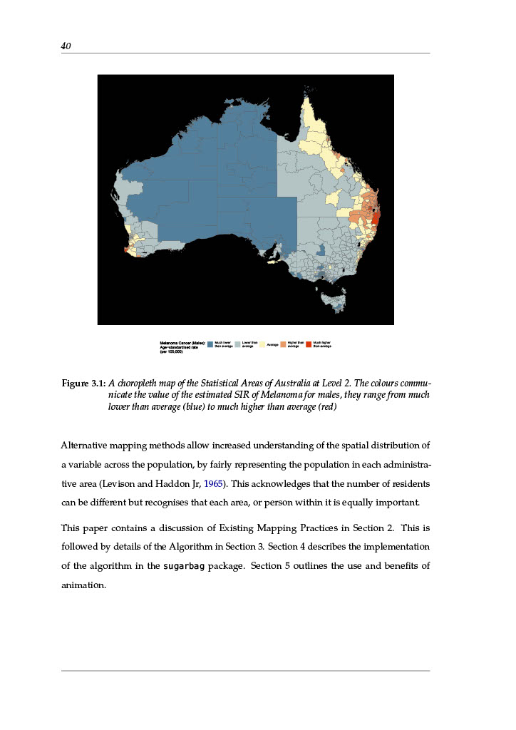

**Appendix  
A1b**

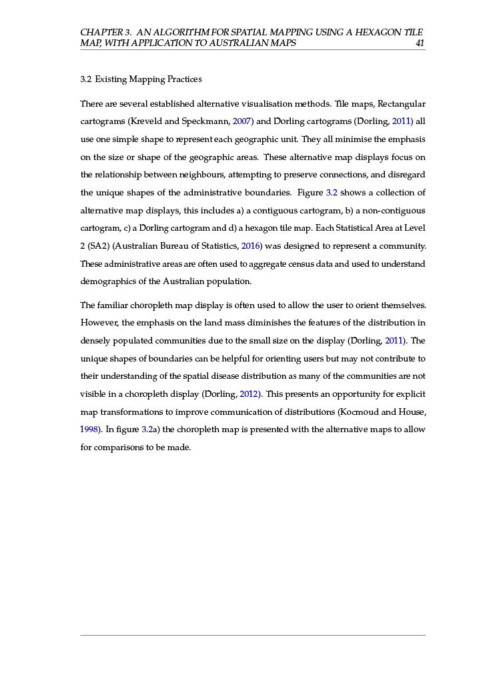 **Appendix  
A2a**

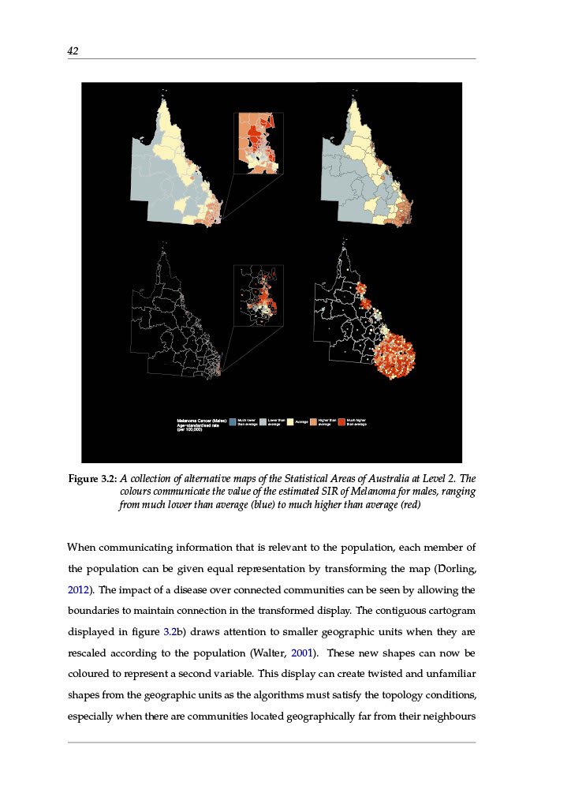 **Appendix  
A2b**

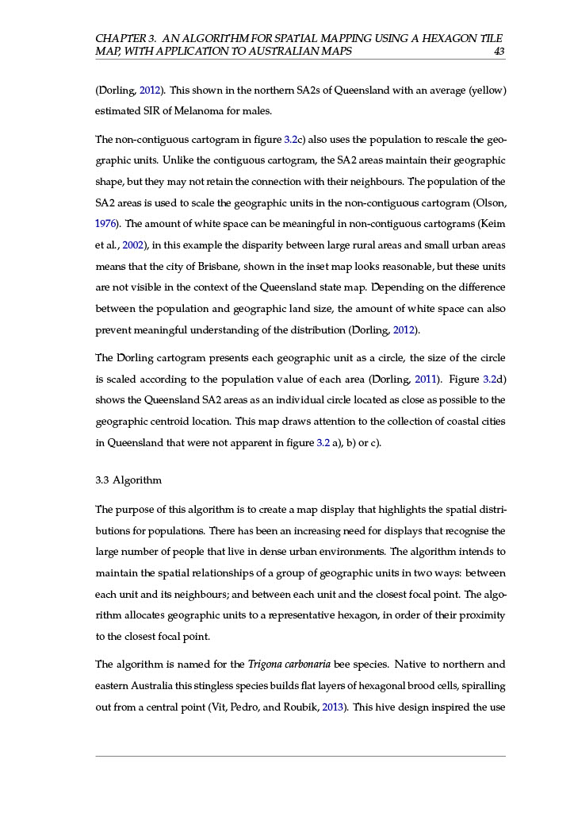

**Appendix  
A2c**

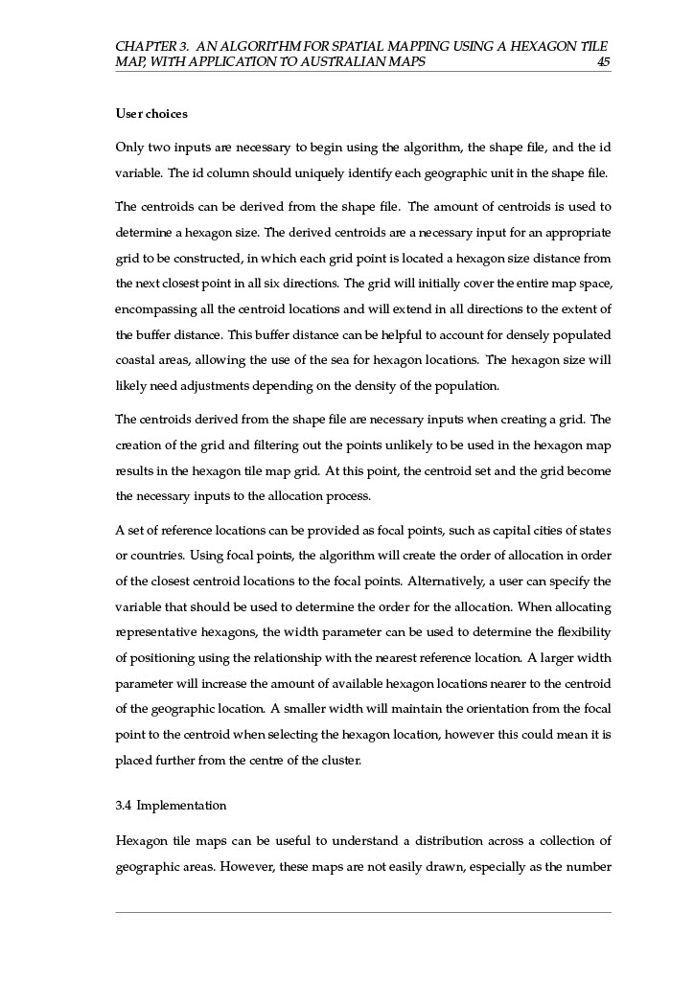

**Appendix  
A2d**

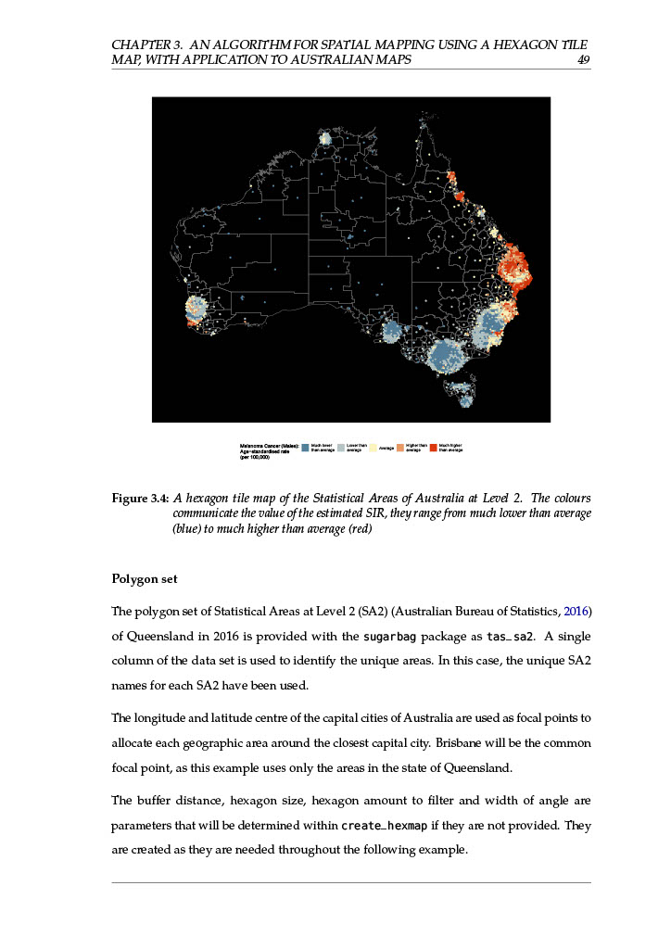  
**Appendix  
A3**

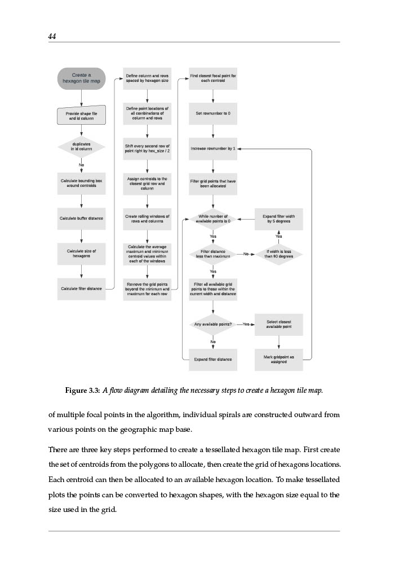

**Appendix  
A4**